Viewing Security Log (Windows 7, Windows Server 2008 R2)

* Open Event Viewer.
* In the console tree, open **Global Logs**, and then click **Security**. The results pane lists individual security events.
* If you want to see more details about a specific event, in the results pane, double-click the event.

Using Windows Auditing to track user activity (AD)

Click **Start** → **Run** and launch **gpedit.msc** MMC console. In a computer, Configuration node, open Windows Settings → Security Settings → Local Policies → Audit Policies folder:

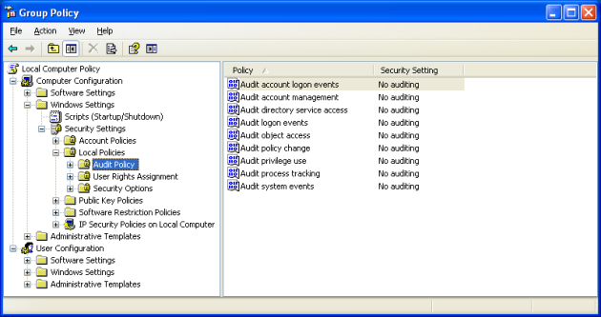

Double-click **Audit object access policy** and select **Success** checkbox. This policy enables file, folder and Windows Registry access attempts that were ended in a success.

Configure auditing for Everyone system group. Open the required shared folder properties and switch to the **Security** tab**. Click Advanced** → **Auditing** and add **Everyone** to the list, then mark both **Delete** (Or whatever access you’d like them to have) checkboxes:

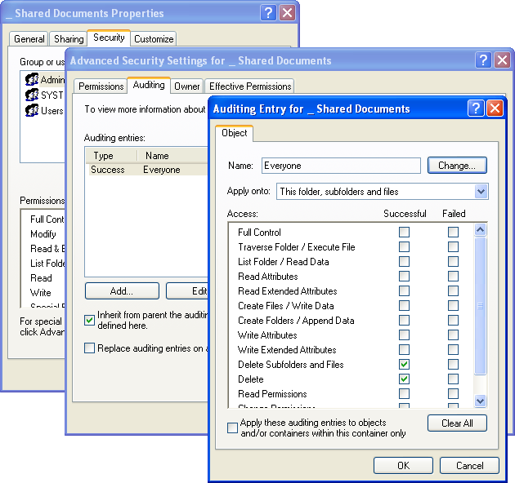

Configure the **Security** event log settings. To do this, click **Start** → **Run** and launch **eventvwr.msc** MMC console. Right-click the Security event log, select Properties and set the following options:

Maximum Log Size = **65536 KB** (for workstations) or **262144 KB** (for servers)

Overwrite events as needed.